# How to do the Groundwater Monthly Report

## Get the data

Option a) update the data yourself

You will need to (ask Mike E-K to get this set up):

* Be a member and a collaborator in github, plus have github desktop installed.
* Have python installed

For the first time you do this, you will need to do a set-up:

Go to the github site <https://github.com/mullenkamp/ecan-water-reports>

Click on the green ‘code’ button and copy the web URL. Open github desktop, file ‘clone repository’ Paste this into github desktop. Change the local path to somewhere on your C:\ drive where you will store your data (mine is C:\Users\philippa\git\ecan-water-reports)

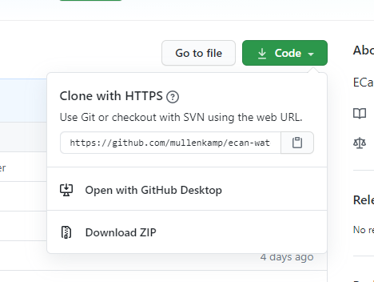 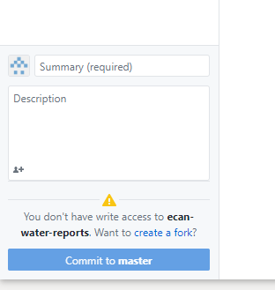

Open the output that went to your C: drive. Open ‘core’ then run ‘install_env.bat’, This will install the python packages and scripts needed for the future.

You will not need to run any of these steps again, from now on you can go to your c: drive and open ‘core’ folder, then run ‘main.bat’. This will now create all the output files you need in your C:drive – see the instructions in option b) below for how to find the shape file. You now need to upload this back to github. Open github desktop and type ‘update’ into the summary field. Then click on the blue ‘commit to master’. If the blue button on the right says ‘pull origin’ – do this, it will make sure your version is the most up-to-date, then push the blue button ‘push origin’. Done!

Option b) Ask Mike E-K (or Philippa or Kurt) to run the script for you

Go to the github site below.

<https://github.com/mullenkamp/ecan-water-reports>

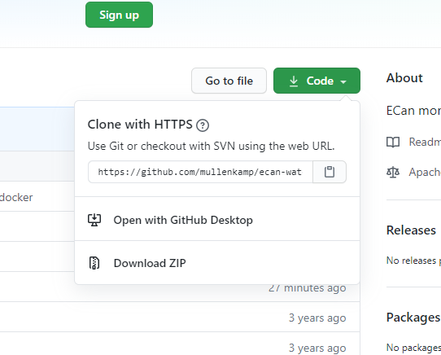

Click on the green code button, and download ZIP

Look in the output_results folder and copy the shape files for the date you have just run e.g. gw_sites_perc_2020-09-04. Make sure you copy all the pieces of the shape file – all 6 files. Paste the files into P:\Groundwater\Freshwater maps

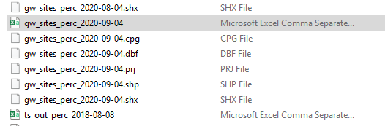

Now open the webpage below (in Chrome) to find out the overall status of each CWMS Zone. <https://ecan-water-reports.readthedocs.io>. Click on the ‘lastest Groundwater CWMS Zone Map on the left hand bar. You can change the month you are looking at the bottom of the map.

## GIS Work

Open the GIS project P:\Groundwater\Freshwater maps\Freshwater Map 2019_rotated, then add the new shape file.

Import a new symbology for the shape file - P:\Groundwater\Freshwater maps\GW_symbology.lyr. Makue sure you use the most recent date as the value field.

Use a definition query to sort ‘shallow wells’ ("depth" = 'Shallow'). Relabel the file in the legend in the existing format (Shallow August 2020). This includes wells screened above 30 m, or with a depth above 30 m if a screen is not present.

Create another copy of the shape file, with the definition query (("depth" = 'Deep'). Import the symbology ‘Deep_gw_symbology.lyr’

Alter the legend in the map to label correctly.

Open the attribute table of the layer ‘CWMS_1’, Add a new text field labelled with the latest month (e.g. August20). Now start editing the data, manually type in the overall state of each CWMS zone based on the webpage you opened earlier. Note you use slightly different terminology for the categories than on the web page, see the table below.

|  |  |
| --- | --- |
| Webpage | GIS |
| Very high | Very high |
| Above average | High |
| Average | Average |
| Below average | Low |
| Very low | Very Low |
| No data | No data |

Now update the symbology for this layer using your latest data. Use the layer ‘Groundwater_areas.lyr’, make sure your value field matches the latest data. You may need to add values, as this layer was created when not all the categories were in the data.

Now copy and paste your layers into the Kaikoura Group layer at the bottom of the project.

Now you have a lovely map! Save the project. Export the image – I usually do one of all the wells turned on, then one of the deep and shallow separately.

## Statistics

Open excel, then open the .dbf file of the shape file (e.g. gw_sites_perc_2019-02-04.dbf). Tidy it up to suit (I remove all the decimal points for example, and cut and paste the columns I need near the start).

Open ‘Data Reporting Freshwater Maps’ in excel. Make a new worksheet for your new month of data by copying an existing sheet and renaming it. Make sure you rename month names in the headings that feed into the graphs.

Use the data from the .dbf file to categorise numbers of wells to fill out the data reporting spreadsheet. You will need to sort by various options of depth, the column with your results (e.g. 2020-08) and CWMS Zone. Note there are formulas running in the worksheet that mean you don’t have to total up everything. I have shaded in orange the cells that need to be entered in the worksheet ‘Aug_2020’.

At this stage, please note if any of your well sites have a blank value for the latest month. This means they were not measured. If they are blank, you will need to go back into your GIS project and manually alter these wells to remove them. This is because GIS will turn a blank value into a ‘0’. The real 0 values are actually lowest ever readings for that month. I fix this in GIS by changing the ‘unreal’ 0 to a 1000, then adding a definition query that excludes values >100.

The categories are in the table below – the .dbf reports the values as percentiles. I include values on the number as the category above (i.e. ‘very low’ is 0 to 9.99, a value of 10 is counted as ‘low).

|  |  |
| --- | --- |
| Very low | 0 – 10 (percentile) |
| Low | 10-25 |
| Average | 25-75 |
| High | 75-90 |
| Very high | 90-100 |

Next update the workbook for M35_1000 with the latest data. Update the long-term average, and make sure the graph is plotting the recent data.

## Reporting

Open last month report (e.g. P:\Groundwater\Freshwater maps\July 2020 State of Groundwater). Resave it with this month’s name. Fill in the text/change the graphs/maps from your statistics work. Make sure you update all the month names where they exist in the text.

I use the snip tool to capture the images for each CWMS zone. Make sure you turn on rivers, roads and place names when at this smaller scale. And add labels to the wells, I use font 10 with 1.5 Halo. I also reset the 30-degree orientation used for the original figures to no rotation (access in GIS under Right click on Layers, data frame properties, general). I make the figures simpler by only showing wells in each CWMS zone, by changing the definition query (e.g. "depth" = 'Shallow' AND "CwmsName" = 'Christchurch - West Melton')

Envelope plots are used to create the graphs, accessed from the tab at the top of the wells database, or O:\Executables\GWL\Envelope. Use the colour option (View, Evolve Summit Colours) and 6 years of data (View, Multiple years, 6 years). I use the snip tool to grab these images as well.

I look at envelope plots for numerous wells in each zone to get an idea of patterns before I write the comment for each zone, then use this to compile the summary comment at the start.

Also look at the statistics for rainfall and river flow in the website <https://ecan-water-reports.readthedocs.io> to help interpret the level data. Also useful is the last month of river flow information on the ECan website.

Lastly create an e-mail with summary information only and send it to GW Science, Hydrology and Tim Davie/Science Group Director. I use the image with both deep and shallow wells together for this e-mail rather than the separate images. An example template e-mail is below.

## E-mail template

Hi Team

*Groundwater levels in August 2020 are low with 87% of wells below the August median.  33% of wells are very low (below the tenth percentile), an increase from 25% of wells in July.  15% of wells were at the lowest levels ever measured in August.  Following a dry winter in many plains areas, little groundwater recharge has occurred and groundwater levels enter the irrigation season at low levels.  We expect groundwater levels to decline with the advent of irrigation pumping.*

*In groundwater areas with little storage such thin aquifers adjacent to rivers, groundwater levels will likely remain low through the irrigation season unless there is a significant recharge event/increased river flow.  These low levels will likely impact on associated spring flows.*

*Plains aquifers with more storage, penetrated by deeper wells, enter the irrigation season at low levels.  Based on the response of the groundwater system to reduced recharge over 2-3 years from 2015-2017, groundwater levels and associated spring flow may remain low this irrigation season, but become very low in subsequent years if no significant winter/spring recharge occurs.*

You can access a fuller report for each CWMS zone here.  Check out rainfall/river flow using Mike’s online reporting tool <https://ecan-water-reports.readthedocs.io> (open in chrome).

Areas I think we need to keep an eye on:

* Waipara – deep wells are still very low
* Christchurch-West Melton – West Melton wells are very very low.  Not sure if the monkeys have escaped yet. Deep wells under the city are low too – but higher towards the coast.  16% of wells in this zone are the lowest ever measured in August.
* Selwyn – The upper plains benefit from Central Plains Water reducing GW abstraction, which is why the only high levels in Canterbury are here.  But groundwater has been very low in the Leeston-Southbridge area for most of 2020 – I imagine this will reflect in lower spring-flow.  Wells by the Selwyn are lower than last month, reflecting low surface flow.
* Ashburton – This zone is really the worst!  Winter recovery has occurred but it is less than in the last few years, levels are similar to 2016/2017 which was a low period.  29% of wells are at the lowest ever measured in August.
* OTOP – Groundwater here is very linked to local river flow, so as this has been low, so are groundwater levels, but this area does ‘bounce back’ quickly if we get some rainfall/river flow.
* Lower Waitaki/SCCS.  Sad little river recharged groundwater systems are getting no recharge so are very very low. 26% of wells at lowest ever for August.

Figure 1: Groundwater levels in Canterbury for July 2020

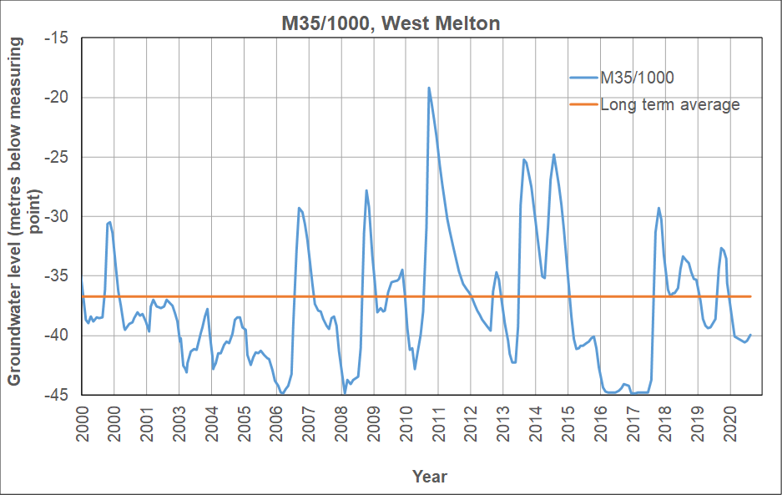

Figure 2: Longer-term groundwater levels in a well at West Melton

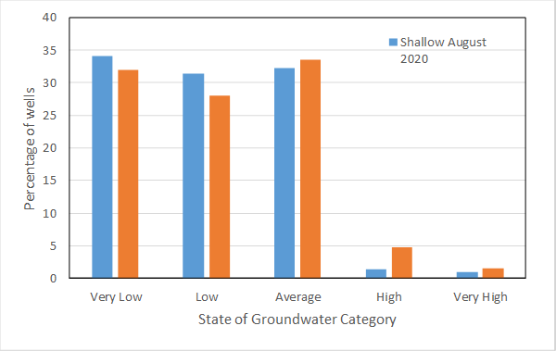

Figure 3: Distribution of groundwater levels.